TASK:1
CODE:

#include <iostream>

#include <string>

using namespace std;

class Device

{

protected:

string deviceID;

string deviceType;

double powerRating;

bool status;

public:

// parameterized constructor using initializer list

Device(string id, string type, double rating)

: deviceID(id), deviceType(type), powerRating(rating), status(false)

{}

// declaring funcs virtual in this base class cuz they are going to be

overrride

virtual void turnOn() { status = true; }

virtual void turnOff() { status = false; }

virtual double calculatePowerUsage(int hours) = 0;

string getType() const { return deviceType; }

string getID() const { return deviceID; }

virtual ~Device() {}

};

class Light : public Device

{

public:

// using light class constructor to assign values to base class members

Light(string id, string type, double rating)

: Device(id, type, rating) {}

// function overriding

void turnOn() override

{

status = true;

cout << deviceType << " [ID: " << deviceID << "] turned ON." << endl;

}

void turnOff() override

{

status = false;

cout << deviceType << " [ID: " << deviceID << "] turned OFF." <<

endl;

}

double calculatePowerUsage(int hours) override

{

return powerRating * hours;

}

};

class Fan : public Device

{

int speedFactor;

public:

Fan(string id, string type, double rating, int speed)

: Device(id, type, rating), speedFactor(speed) {}

void turnOn() override

{

status = true;

cout << deviceType << " [ID: " << deviceID << "] turned ON at Speed "

<< speedFactor << "." << endl;

}

void turnOff() override

{

status = false;

cout << deviceType << " [ID: " << deviceID << "] turned OFF." <<

endl;

}

double calculatePowerUsage(int hours) override

{

return powerRating * hours * speedFactor;

}

};

class AirConditioner : public Device

{

double desiredTemp;

double currentTemp;

public:

AirConditioner(string id, string type, double rating, double desired)

: Device(id, type, rating), desiredTemp(desired), currentTemp(30) {}

void turnOn() override

{

status = true;

cout << deviceType << " [ID: " << deviceID << "] turned ON. Cooling

to " << desiredTemp << "°C." << endl;

}

void turnOff() override

{

status = false;

cout << deviceType << " [ID: " << deviceID << "] turned OFF." <<

endl;

}

double calculatePowerUsage(int hours) override

{

return powerRating * hours * (1 - (currentTemp - desiredTemp) / 100);

}

};

// Forward declarations

class MaintenanceTool;

void accessSecurityLogs();

class SecuritySystem : public Device

{

bool securityAlert;

public:

SecuritySystem(string id, string type, double rating)

: Device(id, type, rating), securityAlert(true) {}

void turnOn() override

{

status = true;

cout << deviceType << " [ID: " << deviceID << "] activated." << endl;

}

void turnOff() override

{

cout << "Authorization required to turn OFF security system." <<

endl;

}

double calculatePowerUsage(int hours) override

{

cout << "Security System: " << powerRating * hours << " Watts

(Includes security checks)" << endl;

return powerRating * hours;

}

// means the below func can access the security sys class memebrs

friend void accessSecurityLogs();

friend class MaintenanceTool;

};

void accessSecurityLogs()

{

cout << "User: U002 - Security Logs Accessed:" << endl;

cout << "- Intrusion Detected at 3:09 AM" << endl;

cout << "- System Reset Required" << endl;

}

// tool class can access security sys calss data

class MaintenanceTool

{

public:

void resetSecurityAlert(SecuritySystem &sys)

{

cout << "Security alerts reset for " << sys.deviceID << endl;

}

};

class User

{

string userID;

string userRole;

int accessLevel;

public:

User(string id, string role, int level)

: userID(id), userRole(role), accessLevel(level) {}

void viewAccessibleDevices()

{

cout << "User: " << userID << " - Accessible Devices:" << endl;

cout << "- LED Light" << endl;

cout << "- Ceiling Fan" << endl;

cout << "- Split AC" << endl;

}

friend void accessSecurityLogs();

};

int main()

{

User user1("U001", "Regular User", 1);

User user2("U002", "Maintenance Staff", 2);

Light light1("L001", "LED Light", 10);

Fan fan1("F001", "Ceiling Fan", 75, 3);

AirConditioner ac1("AC001", "Split AC", 1500, 25);

SecuritySystem secSys1("S001", "Home Alarm", 100);

light1.turnOn();

fan1.turnOn(); ac1.turnOn(); secSys1.turnOn();
cout << "Power Consumption:" << endl;

cout << "LED Light: " << light1.calculatePowerUsage(5) << " Watts" << endl;
cout << "Ceiling Fan: " << fan1.calculatePowerUsage(3) << " Watts" << endl;
cout << "Split AC: " << ac1.calculatePowerUsage(6) << " Watts" << endl; secSys1.calculatePowerUsage(24);
user1.viewAccessibleDevices(); accessSecurityLogs();
return 0;

}

OUTPUT:

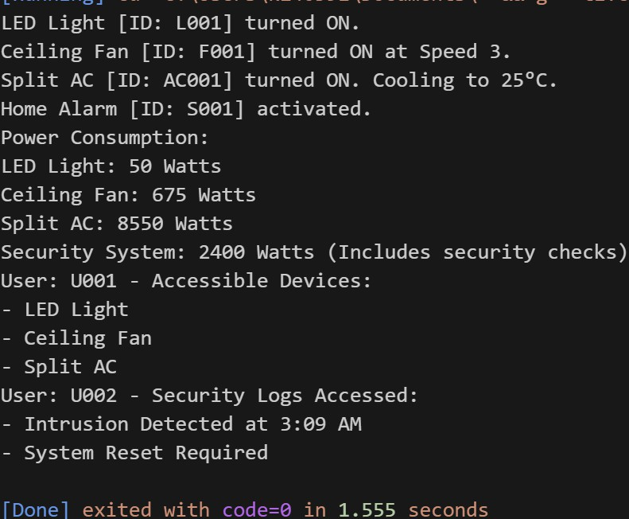

TASK:2
CODE:
#include <iostream>
using namespace std;
class account
{
private:
double balance;
string name;

public:
account(double b, string n) : balance(b), name(n) {}
void deposit(double amo)
{
balance += amo;
}
void withdaw(double amo)
{
if (balance >= amo)
{
balance -= amo;
cout << "amount deducted:" << amo << endl;
}
else
{
cout << "Sorry not enough balance" << endl;
}
}
double operator+(const account& a)
{
return balance + a.balance;
}
bool operator>(const account& a)
{
if (balance > a.balance)
{
return true;
}
else
{
return false;
}
}
account operator-=(double amo){
if(balance>amo){
balance-=amo;
cout<<"amount deducted and transferred"<<endl;
}
else{
cout<<"not enough balance to transfer"<<endl;
}
}
friend ostream &operator<<(ostream &os, const account &a);
};
ostream &operator<<(ostream &os, const account &a)
{
os << a.balance<<"\t";
os << a.name;
return os;
}
int main()
{
account a1(200.98, "Tayyab");
account a2(2300.0, "Yahya");
// using + operator for user defined datatype: class
double b = a1 + a2;
cout << "combined balance of both accounts:" << b << endl;
//using -= operator
a2-=300;
// using > operator
bool a = a1 > a2;
if (a)
{
cout << "account a1 has more balance" << endl;
}
else
{
cout << "account a2 has more balance" << endl;
}
// using << operator
cout << "a1 account holder detail:" << a1 << endl;
cout << "a2 account holder detail:" << a2 << endl;
return 0;
}

OUTPUT:
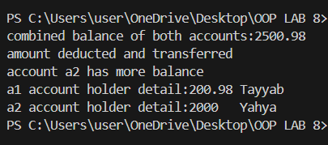

TASK:3
Q1 Answer:
No, a friend function cannot directly modify the invoking (left-hand) object, because it does not have an implicit this pointer.
Operators like +=, -=, *=, etc. modify the left operand, which corresponds to the calling object in a member function.
Hence, such operators should be overloaded using member functions, not friend functions.
Justification with Code:
#include <iostream>
using namespace std;
class Account {
private:
double balance;
public:
Account(double b = 0) : balance(b) {}
// Correct way: member function (modifies invoking object)
Account& operator+=(double amount) {
balance += amount;
return *this;
}
void show() const { cout << "Balance: " << balance << endl; }
};
int main() {
Account a1(1000);
a1 += 500; // Works: modifies a1 directly
a1.show();
return 0;
}

Q2 Answer:

Yes, a friend function can be used when one operand is a primitive type, because member functions only work when the left operand is a class object.
Friend functions allow symmetric behavior such as object + int and int + object.

Justification with Code:
#include <iostream>
using namespace std;

class Account {
private:
double balance;

public:
Account(double b = 0) : balance(b) {}

friend Account operator+(const Account &a, int x);
friend Account operator+(int x, const Account &a);

void show() const { cout << "Balance: " << balance << endl; }
};

// object + int
Account operator+(const Account &a, int x) {
return Account(a.balance + x);
}

// int + object
Account operator+(int x, const Account &a) {
return Account(a.balance + x);
}

int main() {
Account a1(1000);
Account a2 = a1 + 500; // object + int
Account a3 = 500 + a1; // int + object
a2.show();
a3.show();
return 0;
}

Q3 Answer:

No, a friend function cannot access private or protected members without an object, because those members belong to a specific instance of the class.
A friend function only gains permission to access them, but still needs an object to do so.

Justification with Code:
#include <iostream>
using namespace std;

class Account {
private:
double balance;

public:
Account(double b = 0) : balance(b) {}
friend void showBalance(const Account &a);
};

void showBalance(const Account &a) {
// Access through object 'a'
cout << "Balance: " << a.balance << endl;
}

int main() {
Account a1(1200);
showBalance(a1); // Valid way: accessing through object
// showBalance(); // Not valid: needs an object
return 0;
}

